NEMOH

User manual

A. Babarit, January 2014

License

Copyright 2014 Ecole Centrale de Nantes, 1 rue de la Noë, 44300 Nantes, France

NEMOH is licensed under the Apache License, Version 2.0 (the "License"); you may not use the software except in compliance with the License.
You may obtain a copy of the License at

http://www.apache.org/licenses/LICENSE-2.0

The software distributed under the License is distributed on an "AS IS" BASIS, WITHOUT WARRANTIES OR CONDITIONS OF ANY KIND, either express or implied. See the License for the specific language governing permissions and limitations under the License.

The software has been written by G. Delhommeau,P. Guével, J.C. Daubisse, J. Singh, A. Babarit

Important information

Executables are provided in the Release/ folder. They are supposed to be run on a win32 platform.

Source code has been written in Fortran 90. Source code is formatted for compilation with intel fortran in the Windows environment. Compilations should be possible in the Linux environment with limited effort (formatting issues).

1. Running Nemoh with Matlab

It is the easiest way to start with Nemoh. In the folder matlab routines/, one will find m files for generating meshes and running Nemoh with it.

Mesh generation

One may use axiMesh.m to generate an axisymmetric mesh with Matlab. Non axisymmetric meshes may be generated using Mesh.m. Type help axiMesh or help Mesh in Matlab to obtain guidance in using these routines.

Nemoh

Both mesh generators will generate the appropriate folder structure and input files, so that Nemoh can be used right after having generated the mesh. The routine Nemoh.m is a Matlab wrapper for Nemoh. It takes care of the calculations and imports results (hydrodynamic coefficients) in the Matlab environment. Type help Nemoh in Matlab for guidance.

2. Running Nemoh in command line

Software overview

The BEM software Nemoh is composed of three programs. They are supposed to be run one after the other:

Preprocessor

Solver
Postprocessor
Prepare the mesh and the calculation cases (normal velocities files)
For each calculation case, solve the BVP for the potential and calculate hydrodynamic coefficients
Postprocess the results. For instance, calculate the RAOs, plot the free surface elevation, …
Examples can be found in the folder Verification/.

Prerequisites

It is assumed that there exists a file ID.dat in the working folder where the codes are run. This file contains a folder name where the data will be stored. The format is the following:

ID.dat

N ! number of characters of the name of the run (e.g ‘4’)
Name ! name of the working folder (for instance ‘test’)

Before running the code, there must exist a folder called name in which are located the input files Nemoh.cal and input.txt. The format of these files is explained in the following.

Of course, the software requires a mesh as an input. The mesh format is the same as for the L12.dat. Mesh file may be generated by hand, by using the AxiMesh.m or the Mesh.m Matlab routines, or by using the Mesh.exe mesh generation program. For help with Matlab routines, see chapter 1.

Preprocessor

The aim of this program is to prepare the mesh and to generate the input files corresponding with each calculation cases. They are all defined in the input file Nemoh.cal, stored in the folder folder name.

Nemoh.cal

--- Environment -------------------------------------------------------------------------
1025.0 ! RHO ! KG/M**3 ! Sea water density
9.81 ! G ! M/S**2 ! Gravity
0. ! DEPTH ! M ! Water depth (0 for deep water)
0. 0. ! XEFF YEFF ! M ! Wave measurement point
--- Description of floating bodies ------------------------------------------------------
1 ! Number of bodies
--- Body 1 ------------------------------------------------------------------------------
Meshes\Cylinder.dat ! Name of mesh file
500 280 ! Number of points and number of panels
6 ! Number of degrees of freedom
1 1. 0. 0. 0. 0. 0. ! 1 for translation, 2 for rotation followed by direction vector and axis for rotation. In this example, it is surge
1 0. 1. 0. 0. 0. 0. ! Sway
1 0. 0. 1. 0. 0. 0. ! Heave
2 1. 0. 0. 0. 0. -7.5 ! Roll about gravity centre
2 0. 1. 0. 0. 0. -7.5 ! Pitch about gravity centre
2 0. 0. 1. 0. 0. -7.5 ! Pitch about gravity centre
6 ! Number of resulting generalised forces
1 1. 0. 0. 0. 0. 0. ! Force along x axis
1 0. 1. 0. 0. 0. 0. ! Force along y axis
1 0. 0. 1. 0. 0. 0. ! Force along z axis
2 1. 0. 0. 0. 0. -7.5 ! Moment force along x axis about gravity centre
2 0. 1. 0. 0. 0. -7.5 ! Moment force along y axis about gravity centre
2 0. 0. 1. 0. 0. -7.5 ! Moment force along z axis about gravity centre
0 ! Number of lines of additional information
--- Load cases to solve ---------------------------------------------------------------
41 0.1 2. ! Number of wave frequencies, Min, and Max (rad/s)
1 0. 0. ! Number of wave directions, Min and Max (degrees)
--- Post processing -------------------------------------------------------------------
1 0.1 10. ! IRF ! IRF calculation (1 for yes), time step and duration
1 ! Show pressure on body surface (1 for yes)
181. 0. 180. ! Kochin function ! Number of directions (0 for no), Min ,Max (°)
0 50 100. 100. ! Free surface vizualisation ! Number of points in x direction (0 for no calculations) and y direction and dimensions of domain in x and y direction

After running the program, the results of the Preprocessor will be the following files, stored in the folder folder_name. Details of the formatting are given in the appendix.

Mesh/L12.dat : This is one of the two mesh files. It contains the table of nodes coordinates and the table of connectivities.
Mesh/L10.dat : This is the second mesh file. It contains additional geometrical information such as symmetry about the (xOz) plane, number of nodes, number of panels, number of bodies, panel to body relation, panel centres, panel normal vectors, panel areas.
Mesh/Mesh.tec : Allow visualisation of the mesh using Tecplot.
Normalvelocities.dat : This file contains each radiation and diffraction problem defined in Nemoh.cal that have to be solved by the Solver.
Integration.dat This file contains the information about how the pressure must be integrated to obtain the requested forces.
Results/FKForce.dat: This file contains the Froude-Krylov force associated with each diffraction problem.
Results/FKforce.tec: Allow visualisation of the Froude-Krylov force using Tecplot.
Radiationcases.dat: This file contains the normal velocities on each panel corresponding with the cases defined in the input file
Mesh/FreeSurface.datThis file contains the coordinates of the points of the free surface where to calculate the wave elevation
Mesh/Kochin.dat This file contains the discretisation for the calculation of the Kochin function
Results/index.dat This file contains the correlation between force ID number, ID of body on which it applies and number in the Nemoh.cal file. It also contains the correlation between ID radiation problem, ID of body which is actually moving, and number of degree of freedom.

Solver

The aim of this program is to solve the BVP for each problem defined in the file Normalvelocities. The calculation depends on some parameters which are read in the file input.txt. This file must be located in the folder folder_name.

Input.txt

--- Calculation parameters --------------------------------------------------------------
0 ! Indiq_solver ! - ! Solver (0) Direct Gauss (1) GMRES (2)
20 ! IRES ! - ! Restart parameter for GMRES
5.E-07 ! TOL_GMRES ! - ! Stopping criterion for GMRES
100 ! MAXIT ! - ! Maximum iterations for GMRES
1 ! Sav_potential ! - ! Save potential for visualization (1 for yes)

After running the program, After execution, the results will be the following files, stored in the folder folder name/.

Results/Forces.dat: This file contains the forces associated with each diffraction problem.
Results/freesurface.XX.dat: This file contains the free surface elevation for problem XX.
Results/Kochin.XX.dat: This file contains the Kochin function for corresponding to problem XX.
Results/Potential.XX.dat: This file contains the potential on body surface for problem XX.

Postprocessor

The aim of this program is to postprocess the results in order to provide the relevant quantities (added mass, radiation damping, excitation force) in the usual format. It also provides a framework to make relevant calculations. For instance, the aim can be to calculate the RAOs of the floating bodies and to plot the corresponding far field wave elevation.

After running the program, the results will be the following files, stored in the folder folder name/.

Results/RadiationCoefficients.tec: This file contains the added mass and damping coefficients for each force and each radiation problem.
Results/DiffractionForce.tec: This file contains the diffraction force on each body for each diffraction problem.
Results/ExcitationForce.tec: This file contains the excitation force on each body for each excitation problem.

3. Appendix
L12.dat (or mesh file)
2 0 ! Second number is 1 if a symmetry about the (xOz) plane is used
1 1. 2. 3. ! Table of nodes ! ID of Node | Xcoordinates | Y | Z
. . . . !
. . . .
. . . .
0 0 0 0 ! Last line of table of nodes
1 2 3 4 ! Table of connectivities ! ID of Node1 | Node2 | Node3 | Node4
. . . . !
. . . .
. . . .
0 0 0 0 ! Last line of table of panels

Node 1
Node 2
Node 3
Node 4
L10.dat
0 40 10 2 ! 1 for symmetry | Nb of nodes | Nb of panels | Nb of bodies
1 0. 0. -5. 0. 0. -1. 1. !
. . . . . . . . !
. . . . . . . . !
. . . . . . . . !
2 0. -5. -2.5 0. -1. 0. 1. !

Body to which belong the panel | X Y Z coordinate of the panel centre | NX NY NZ coordinates of normal vector | Panel area
Normalvelocities.dat
1000 ! (Nb of diffraction problems + Nb of radiation problems) * Nb of wave frequencies
1. 1. 1. 2. 2. 2. ! Wave frequencies for each of problem
3.14 -1. -1. 3.14 -1. -1. ! If diffraction problem, incident wave direction in °, -1. if radiation
0 1 1 0 1 1 ! Switch to 1 if potential will be saved
1 0 0 1 0 0 ! Switch to 1 to calculate free surface elevation
1 1 1 1 1 1 ! Switch to 1 to calculate the Kochin function
0.1 0.2 1. 0. 1. 0. 0.3 0.4 1. 0. 1. 0. ! Real and imaginary part of the normal vector for each panel
. . . . . . . . . . . . ! Be careful if symmetry. With symmetry information is given
. . . . . . . . . . . . ! for both the described and symmetric part of the mesh
0.5 0.6 1. 0. 1. 0. 0.7 0.8 1. 0. 1. 0. !
Integration.dat
Lines are forces
Columns are contribution of each panel to the force.
Be careful if symmetry. If symmetry, information is given for both described and symmetric part of the mesh.
Result/FKForce.dat
Lines are the forces
Columns are the diffraction problems
Test cases

1. Cylinder
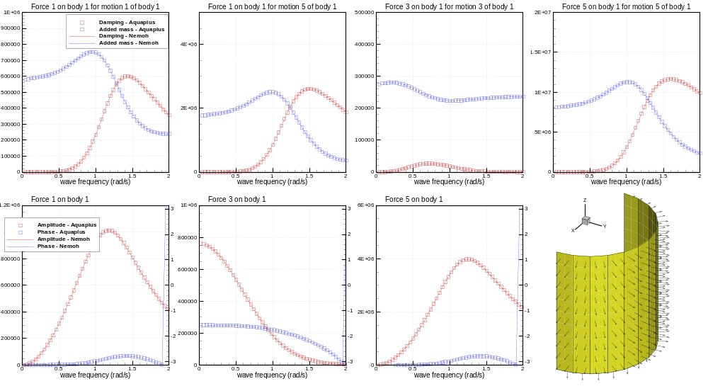
2. 2 Bodies
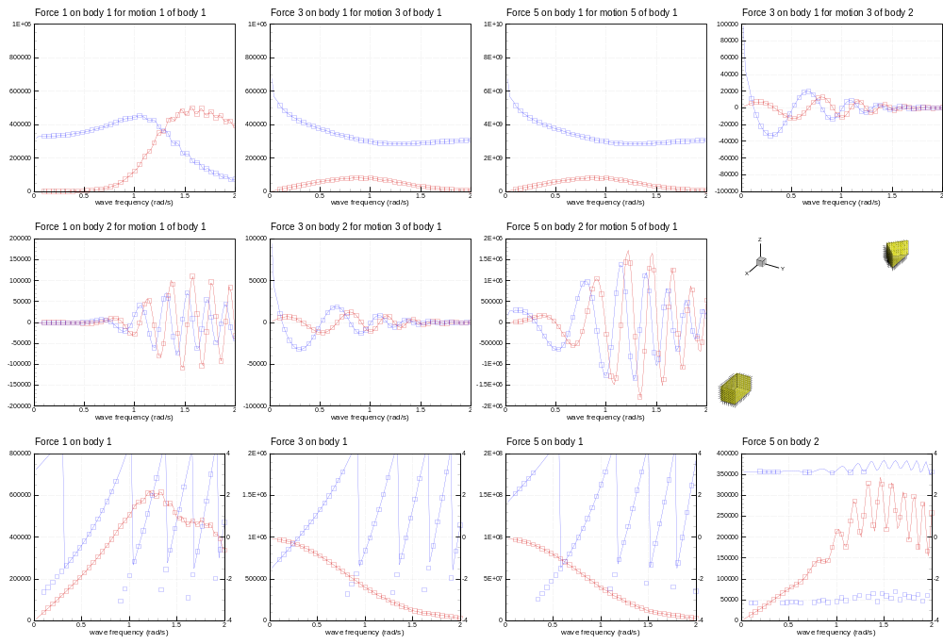
3. Non symmetrical body
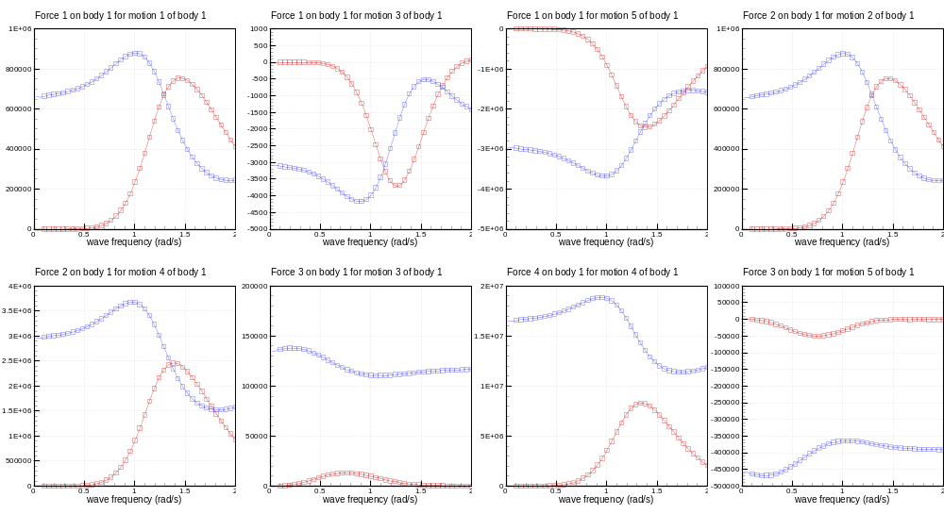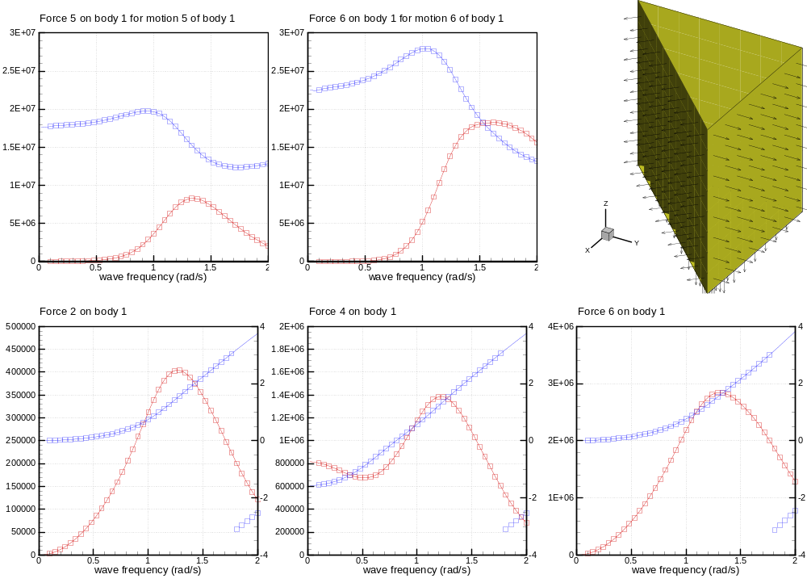
4. Postprocessing
